**JDBC AND MS Access with a JTable**

**Step 1 Open Access**

**Create Database File named: MyData.accdb**

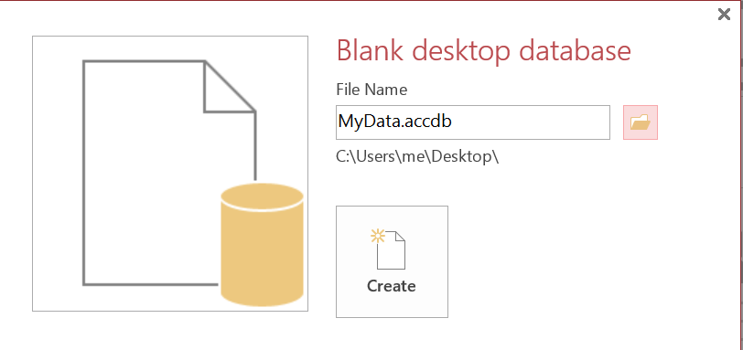

**Save to Desktop**

**Step 2 Create Database Table**

**Access Menu: [ Create ] -> [Queries ] group -> [Query Design] link**

**Close Show Table dialog box**

**Click SQL view**

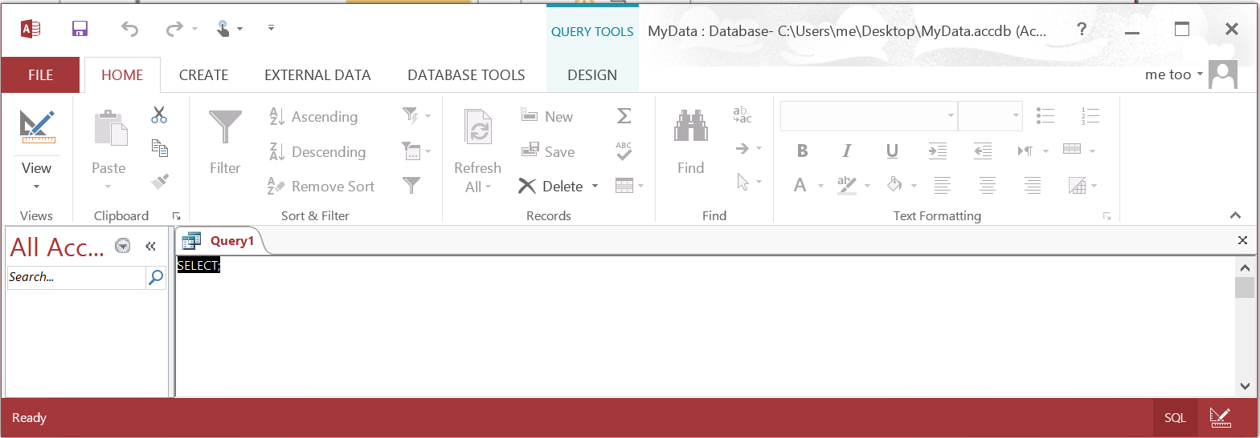

**Execute the CREATE Table script**

**CREATE TABLE data**

**(**

**RollNo Integer NOT NULL,**

**SName CHAR(25),**

**GPA DOUBLE,**

**PRIMARY KEY (RollNo)**

**);**

**Run Query [ ! ]**

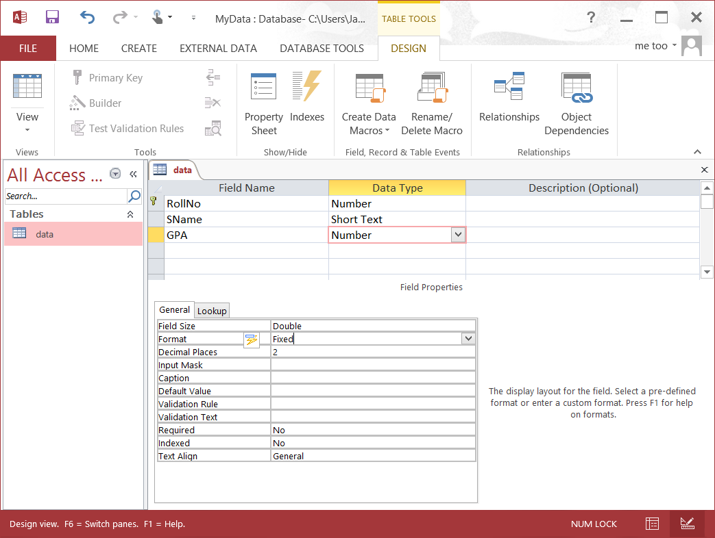

**Set Decimal Places (Fixed) to 2 for the GPA field**

**Close Table but keep Access open**

**Step 3 Populate Database Table**

**INSERT INTO data (RollNo, SName, GPA)**

**VALUES (101, 'patel', 3.20);**

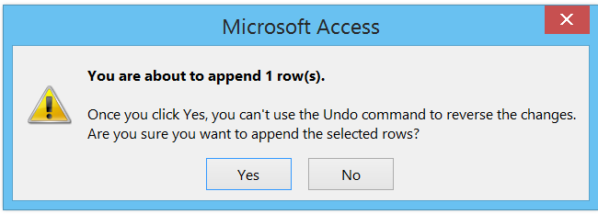

**INSERT INTO data (RollNo, SName, GPA)**

**VALUES (102, 'singh', 3.10);**

**INSERT INTO data (RollNo, SName, GPA)**

**VALUES (103, 'smith', 3.45);**

**INSERT INTO data (RollNo, SName, GPA)**

**VALUES (104, 'pappas', 2.25);**

**INSERT INTO data (RollNo, SName, GPA)**

**VALUES (105, 'diaz', 4.00);**

**Step 4 Observe Access Datasheet**

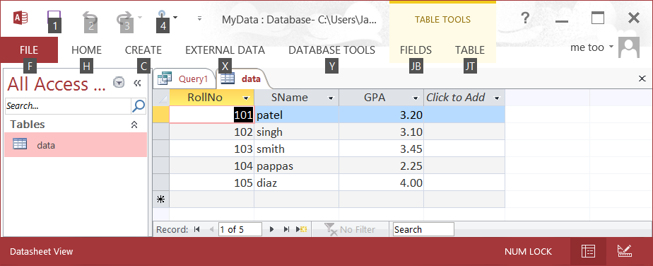

**Step 5 Create Java Application**

**Eclipse - > New Java Project -> JTableAccessDemo**

**Source Code:**

|  |
| --- |
| //import java.awt.*;  **import** java.sql.*;  **import** java.util.*;  **import** javax.swing.*;  //import java.awt.event.*;  **import** javax.swing.table.*;  **public** **class** JTableAccessDemo {  **public** **static** **void** main(String[] args) {  Vector columnNames = **new** Vector();  Vector data = **new** Vector();  JPanel p=**new** JPanel();  **try** {  Class.*forName*("sun.jdbc.odbc.JdbcOdbcDriver");  Connection con = DriverManager.*getConnection*("jdbc:odbc:mydsn");  String sql = "Select * from data";  Statement stmt = con.createStatement();  ResultSet rs = stmt.executeQuery( sql );  ResultSetMetaData md = rs.getMetaData();  **int** columns = md.getColumnCount();  **for** (**int** i = 1; i <= columns; i++) {  columnNames.addElement( md.getColumnName(i) );  }  **while** (rs.next()) {  Vector row = **new** Vector(columns);  **for** (**int** i = 1; i <= columns; i++){  row.addElement( rs.getObject(i) );  }  data.addElement( row );  }  rs.close();  stmt.close();  }  **catch**(Exception e){  System.*out*.println(e);  }  JTable table = **new** JTable(data, columnNames);  TableColumn col;  **for** (**int** i = 0; i < table.getColumnCount(); i++) {  col = table.getColumnModel().getColumn(i);  col.setMaxWidth(250);  }  JScrollPane scrollPane = **new** JScrollPane( table );  p.add( scrollPane );  p.add( scrollPane );  JFrame f=**new** JFrame();  f.add(p);  f.setSize(600,400);  f.setVisible(**true**);  }  } |

**Project Saved to**

**C:\Users\me\workspace**

**Notice: mydsn is the name of our Data Source object for connection purposes.**

**Notice: database table name is data**

**Step 6 Move Database File to Java Project Folder**

**Eclipse - > New Java Project -> JTableAccessDemo**

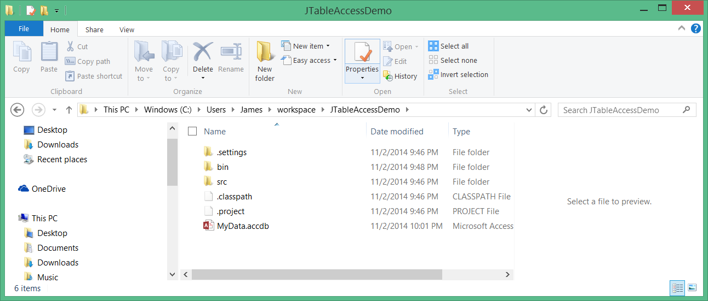

**C:\Users\me\workspace\JTableAccessDemo**

**Step 7 Configure ODBC**

**Open Database Connectivity ( ODBC )**

**Control Panel -> System and Security -> Administrative Tools**

**Select [ ODBC Data Sources (64-bit) ]**

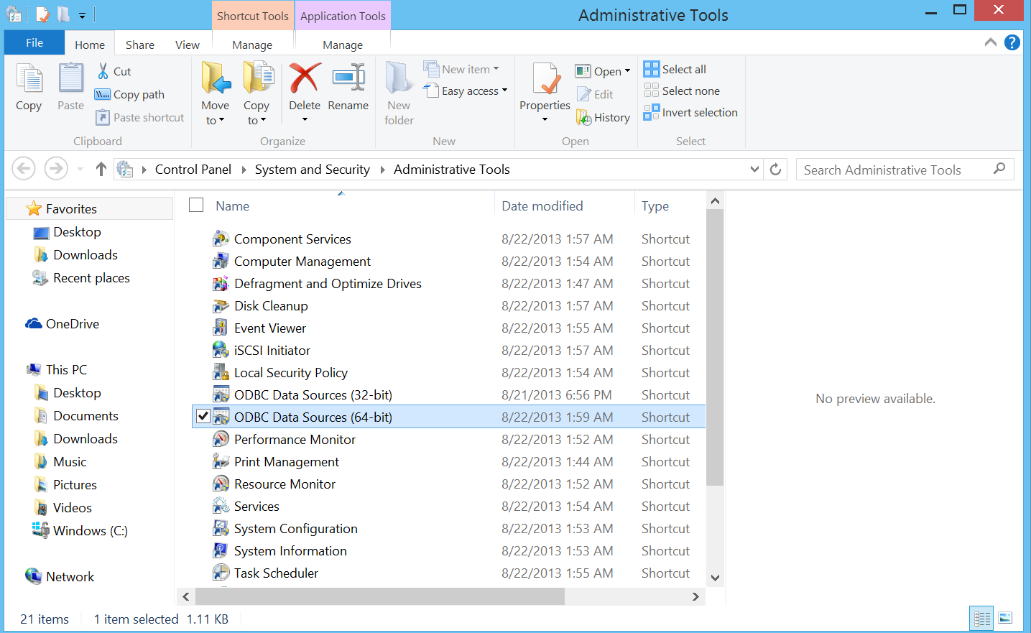

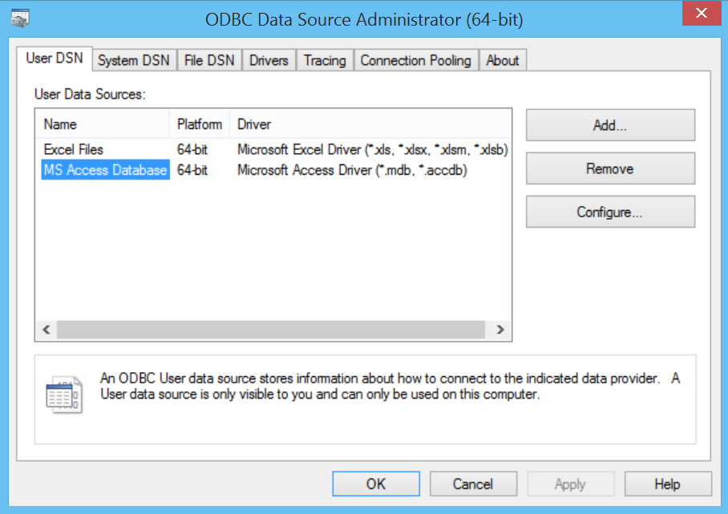

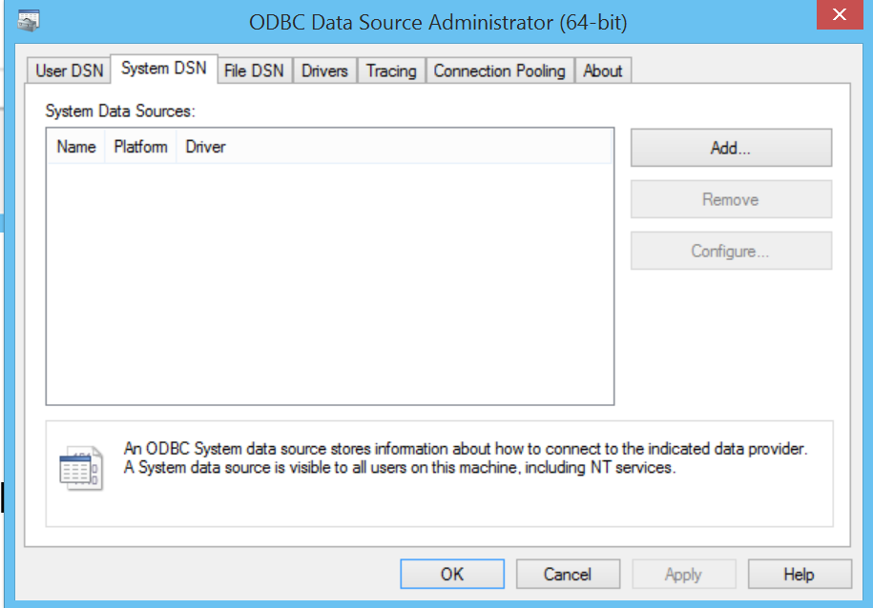

**Click [ System DSN ] tab and click [ Add ]**

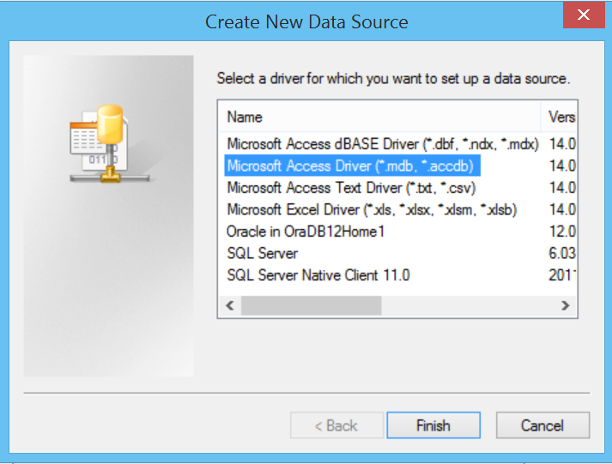

**Select Microsoft Access Driver (*.mdb, *.accdb)**

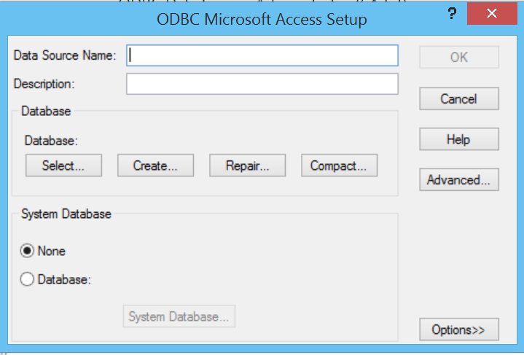

**Data Source Name: mydsn**

**Select Database**

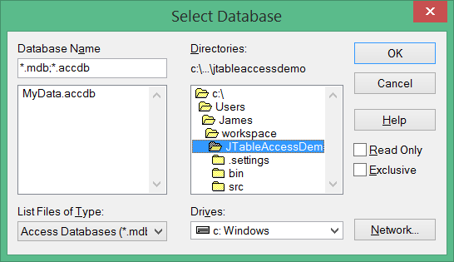

**Configuration Complete**

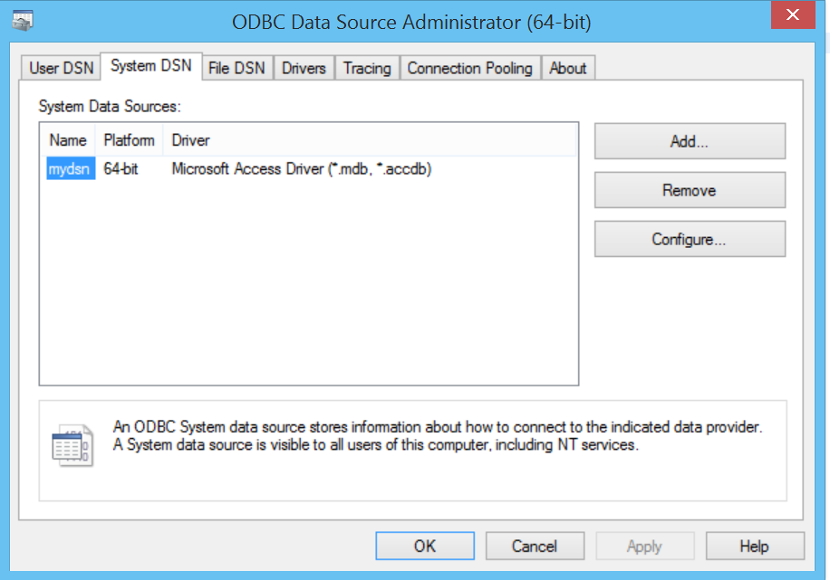

**Note:**

**Download 64 bit ODBC if not available**

**64-Bit OLEDB Provider for ODBC (MSDASQL)**

[**http://www.microsoft.com/en-us/download/details.aspx?id=20065**](http://www.microsoft.com/en-us/download/details.aspx?id=20065)

**Step 8 Run JDBC / ODBC / MS Access Java Application**

**Observe output in Java IDE**

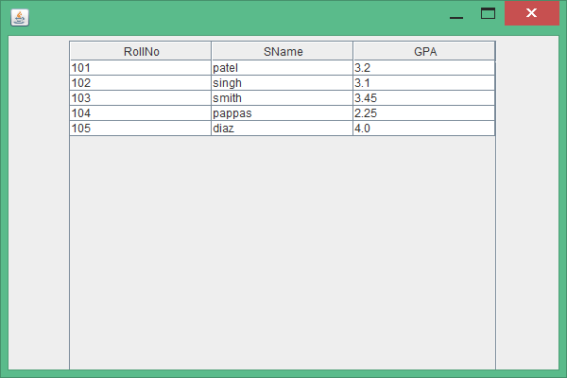

**Step 10 Observe MS Access Record - Locking File**

